EX. NO: | SIMPLE CALCULATOR APP USING REACT JS
DATE: | SIMPLE CALCULATOR APP USING REACT JS

AIM:
To build a simple calculator application using React JS that performs basic arithmetic operations like addition, subtraction, multiplication, and division.

ALGORITHM:

STEP 1: Create a new React project using Vite.
STEP 2: Open the project in VS Code.
STEP 3: Create a calculator component in App.jsx.
STEP 4: Use useState() to store user input and result.
STEP 5: Create buttons for numbers and arithmetic operators.
STEP 6: Display the entered values in the calculator screen.
STEP 7: Perform calculation using arithmetic expressions.
STEP 8: Add clear (C) and equal (=) buttons.
STEP 9: Style the calculator using CSS.
STEP 10: Run the application using npm run dev.

PROGRAM CODE:

App.jsx
import { useState } from "react";
import "./App.css";

function App() {
const [input, setInput] = useState("");

const handleClick = (value) => {
setInput(input + value);
};

const clearInput = () => {
setInput("");
};

const deleteLast = () => {
setInput(input.slice(0, -1));
};

const calculate = () => {
try {
setInput(eval(input).toString());
} catch {
setInput("Error");
}
};

return (
<div className="container">
<div className="calculator">
<h1>🧮 Calculator</h1>

<input
type="text"
value={input}
readOnly
className="display"
/>

<div className="buttons">
<button className="top-btn" onClick={clearInput}>
C
</button>

<button className="top-btn" onClick={deleteLast}>
⌫
</button>

<button
className="operator"
onClick={() => handleClick("/")}
>
÷
</button>

<button
className="operator"
onClick={() => handleClick("*")}
>
×
</button>

<button onClick={() => handleClick("7")}>7</button>
<button onClick={() => handleClick("8")}>8</button>
<button onClick={() => handleClick("9")}>9</button>

<button
className="operator"
onClick={() => handleClick("-")}
>
−
</button>

<button onClick={() => handleClick("4")}>4</button>
<button onClick={() => handleClick("5")}>5</button>
<button onClick={() => handleClick("6")}>6</button>

<button
className="operator"
onClick={() => handleClick("+")}
>
+
</button>

<button onClick={() => handleClick("1")}>1</button>
<button onClick={() => handleClick("2")}>2</button>
<button onClick={() => handleClick("3")}>3</button>

<button className="equal" onClick={calculate}>
=
</button>

<button
className="zero"
onClick={() => handleClick("0")}
>
0
</button>

<button onClick={() => handleClick(".")}>.</button>
</div>
</div>
</div>
);
}

export default App;

App.css
* {
margin: 0;
padding: 0;
box-sizing: border-box;
}

body {
font-family: Arial, sans-serif;
background: linear-gradient(135deg, #1d2671, #c33764);
}

.container {
height: 100vh;
display: flex;
justify-content: center;
align-items: center;
}

.calculator {
width: 360px;
background: #ffffff;
border-radius: 25px;
padding: 25px;
box-shadow: 0 10px 30px rgba(0, 0, 0, 0.3);
}

.calculator h1 {
text-align: center;
margin-bottom: 20px;
color: #333;
}

.display {
width: 100%;
height: 75px;
border: none;
outline: none;
border-radius: 15px;
background: #f4f4f4;
margin-bottom: 20px;
padding: 15px;
font-size: 30px;
text-align: right;
color: #222;
font-weight: bold;
}

.buttons {
display: grid;
grid-template-columns: repeat(4, 1fr);
gap: 15px;
}

button {
height: 65px;
border: none;
border-radius: 15px;
font-size: 22px;
cursor: pointer;
transition: 0.2s;
background: #f1f1f1;
color: #333;
font-weight: bold;
}

button:hover {
transform: scale(1.05);
}

.operator {
background: #4facfe;
color: white;
}

.operator:hover {
background: #2196f3;
}

.equal {
background: #00c853;
color: white;
grid-row: span 2;
height: 145px;
}

.equal:hover {
background: #00a844;
}

.top-btn {
background: #ff5252;
color: white;
}

.top-btn:hover {
background: #ff1744;
}

.zero {
grid-column: span 2;
}
main.jsx
import { StrictMode } from 'react'
import { createRoot } from 'react-dom/client'
import './index.css'
import App from './App.jsx'

createRoot(document.getElementById('root')).render(
<StrictMode>
<App />
</StrictMode>,
)

OUTPUT:

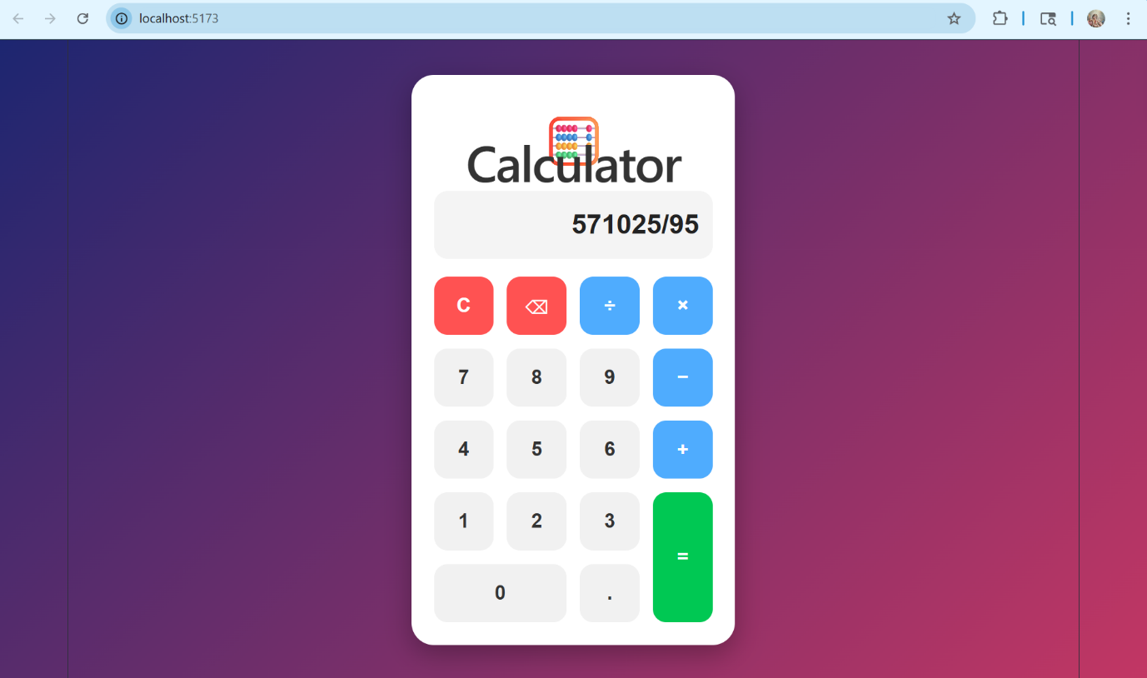

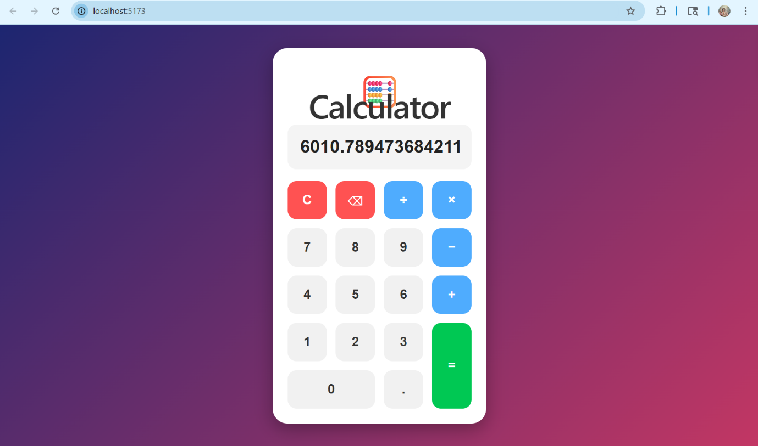

RESULT:
Thus, the simple calculator application using React JS was created and executed successfully.

